Quarterly Report – Public Page

Date of Report: 1st Quarterly Report, January 7, 2025
Contract Number: 693JK32410013POTA
Prepared for: DOT PHMSA
Project Title: Assess and Prevent Threats in Conversion or Repurposing Pipeline Systems
Prepared by: DNV
Contact Information: Greg Morris, greg.morris@dnv.com, 614-761-1214
Tara McMahan, tara.podnar.mcmahan@dnv.com, 614-761-1214
For quarterly period ending: December 31, 2024

1: Items Completed During this Quarterly Period:
Item # | Task # | Activity/Deliverable | Title | Federal Cost | Cost Share
4 | 0 | Kick-off Meeting | Provision of kick-off meeting minutes | 15,000 | 0

2: Items Not-Completed During this Quarterly Period:

Project is on time.

3: Project Financial Tracking During this Quarterly Period:
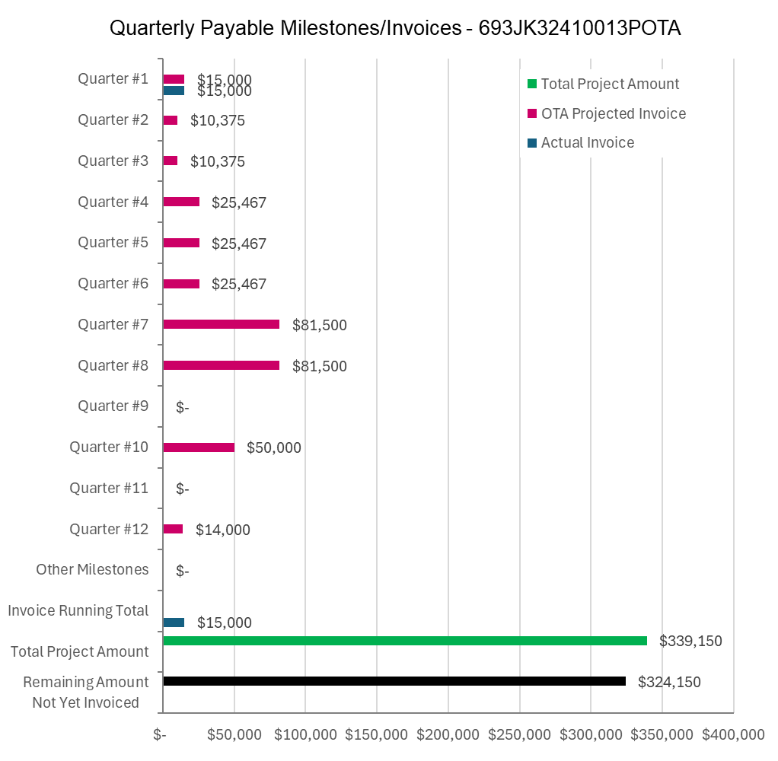

4: Project Technical Status –

DNV held the project kick-off meeting with the project team and TAP on November 11, 2024. Minutes of the kick-off meeting were posted to the project share site on November 21, 2024.

Attachment 2 Project Deliverables:
- Conduct kick-off Team meeting to review project objectives, deliverables, schedule and discuss the roles and responsibilities of each project team and TAP member. Status meeting frequency and agenda will also be defined as a result of the kick-off Team meeting. Meeting minutes from the kick-off meeting will be provided to DOT within three (3) months of the effective date of the Agreement.

5: Project Schedule –

The project is on schedule.

